The ER diagram shows the relationship between the different entity sets. This document describes the different relationships used, participation constraints, ISA relationships and aggregations used. A description of all the tables and the reason for their use is mentioned in the relational model.

**ISA relationships:**

Below is a list of “ISA” relationships we have used:

1. Patron – Student and Faculty

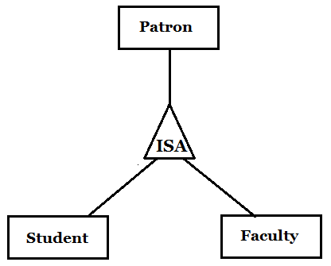

We used the ***ER approach*** to translate the above relationship into tables. Patron table contains the common information and the Student and Faculty table contain information specific to them. This ISA relationship is ***disjoint*** and ***complete***.

1. Resource – Publication, Camera, Room

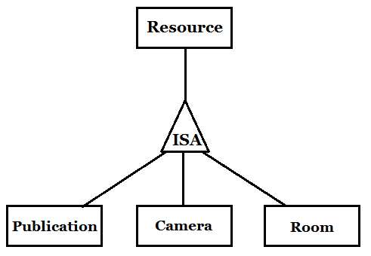

We used the ***ER approach*** to translate the above relationship into tables. Resource table contains a list of the different resources in the system and the individual tables contain information specific to that type of resource. This ISA relationship is ***disjoint*** and ***complete***.

1. Publication – Book, Journal, Conference Paper

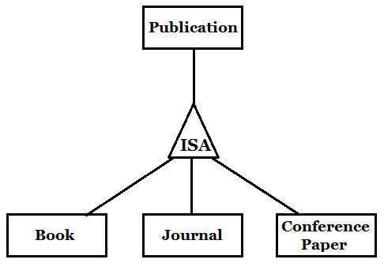

We used the ***Object-oriented approach*** to translate the above relationship into tables. Only individual tables with their respective information is created. No common publications table is created. This ISA relationship is ***disjoint*** and ***complete***.

1. Room – Study, Conference

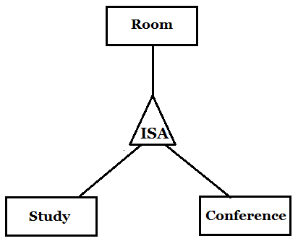

We only created one table for Room and used ***a field in the table*** to specify whether it is a Study or Conference room. This ISA relationship is ***disjoint*** and ***complete***.

**Participation constraints:**

We used three kinds of participation constraints – at most one, at least one and exactly one

***At most one –***

Course (entity) to Teaches (relationship)

A course is taught by at most one faculty

Faculty (entity) to Teaches (relationship)

A faculty teaches at most one course

Reservation (entity) to Estimates Return (relationship)

A reservation estimates return from at most one checkout reference

Reservation (entity) to CalculateLateFee (relationship)

A reservation calculates late fee from at most one late fee reference

Books (entity) to BlockBook (relationship)

A book can be blocked for at most one course by a faculty

***At least one –***

Student (entity) to Enrolled (relationship)

A student must be enrolled in at least one course

***Exactly one –***

Patron (entity) to Belongs to (relationship)

A patron can belong to exactly one department

Student (entity) to Doing (relationship)

A student can be a part of (doing) exactly one program

Course (entity) to Has (relationship)

A course is for exactly one department

Resource (entity) to Present In (relationship)

A resource is present in exactly one library

**Aggregations:**

We used four cases of aggregation – all four have a similar logic. In each case, a patron requests a resource and enters a queue for the resource. Once the reservation is confirmed, that request enters the reservation table.

1. Requests Publication – Enters – Reservation

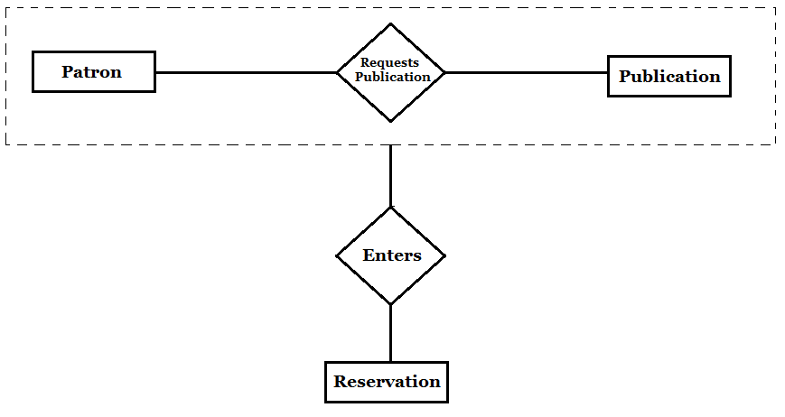

When a patron requests a publication, it enters a queue if that publication has already been checked-out by another patron. Once the reservation is confirmed, the request enters the reservation table.

1. Requests Camera – Enters – Reservation

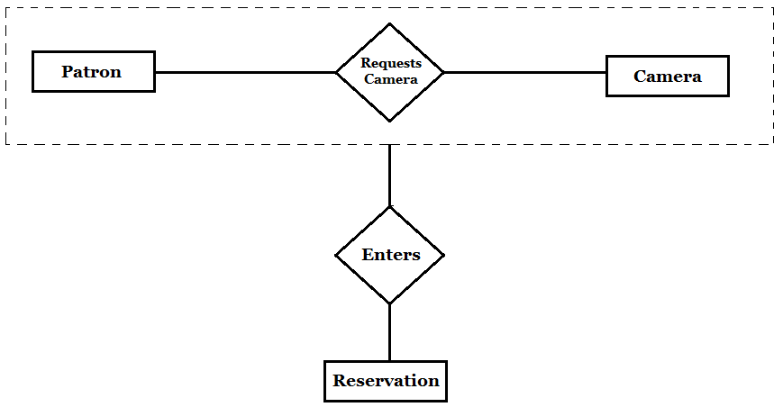

When a patron requests a camera, it enters a queue and the first person in the queue gets the camera at 9am on Friday. When he/she checks out the camera, an entry of the request is made in the reservation table.

1. Requests Room – Enters – Reservation

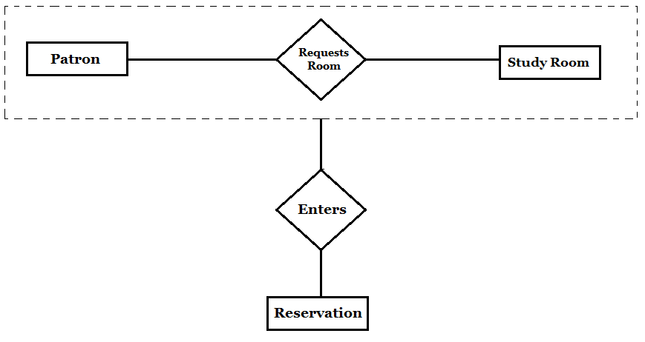

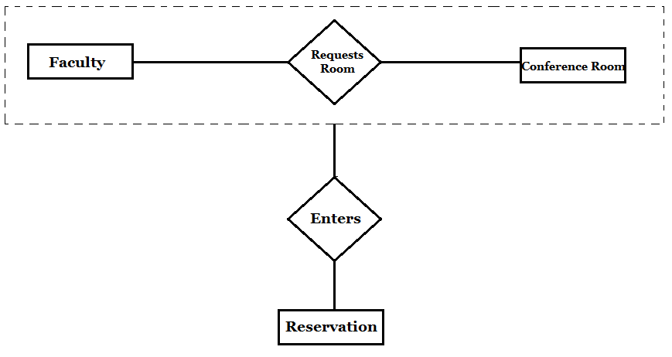

In both the above cases, when a patron requests a room, it enters a separate queue table until the room is checked-out at the time of the reservation. At this point, an entry is made into the reservation table.

**Binary vs Ternary Relationships:**

Most of our relationships are binary. We have used one ternary relationship in our ER diagram between Faculty, Course and Book.

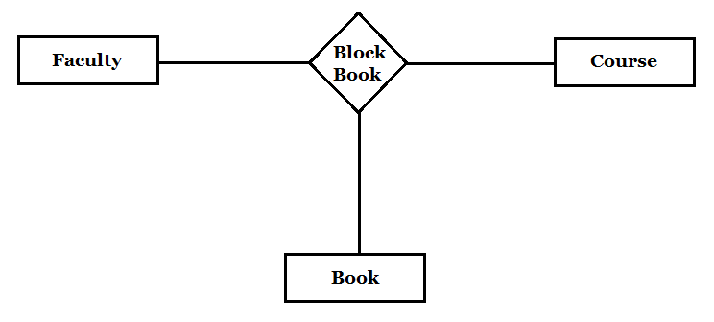

The relationship above shows that a faculty blocks a book for a particular course. This needs to be, and hence has been expressed as a ternary relationship.